Encarnação Alliance

Urban Poor Churchplanters’
Training Consultation
Theology and Practice
of Urban Poor Churchplanting



Trainer____________
Workbook

Place _________________
Date _________
Name: _____________________
Confidential to participant and training coordinators
Registration Details:

Name: Last name: _____________________First names: ______________________________
Date of Birth: day________month _________year___________
Marital status: Single/married/separated/divorced/widowed (Please circle the correct one)
How many children (ages)__________________
Address____________________________________________________________________
__________________________________________________________________________
__________________________________________________________________________
City____________State_____________Postcode_______Country_________
Postal Address if different to the above: __________________________________________________________________________
__________________________________________________________________________

Telephone No: ________________________ Email address: __________________

Educational Qualifications:
Primary School - 5yrs to 12yrs: Yes/No (circle one)
Secondary School – 13 to16yrs+: Yes/No (circle one)
Graduate from Secondary School? Yes/No (circle one)
Do you hold any tertiary qualifications (University, Bible School etc)? Yes/No (circle one)
Qualification and the year attained.
__________________________________________________________________________
__________________________________________________________________________
__________________________________________________________________________
__________________________________________________________________________
Community Service details:
Have you served in any community service roles whether paid or voluntary?
Please state the details, names of organisation, roles, dates of service etc.
__________________________________________________________________________
__________________________________________________________________________
__________________________________________________________________________
__________________________________________________________________________
Name of organisation/church you work for or are associated with:
__________________________________________________________________________
__________________________________________________________________________
Postal address of that organisation/church____________________________________________________________
__________________________________________________________________________
__________________________________________________________________________
Name of the leader you are accountable to: ______________________
Do you have a spiritual mentor/supervisor? Yes/ No
If you answer was Yes, please provide details of the mentor/supervisor;
Name:__________________________________________________ PostalAddress__________________________________________________________________________________________________________________________________________
__________________________________________________________________________
Tel. No. __________________Email Address:___________________

Christian history:
When did you become a Christian? Year________
When were you baptised? Year_______
When did you become a Church member? Year_______
How long have you been a Church leader? Years_______
What experience have you had as an urban poor church planter?
__________________________________________________________________________
__________________________________________________________________________
__________________________________________________________________________
__________________________________________________________________________What experience have you had as an urban poor church worker?
__________________________________________________________________________
__________________________________________________________________________
__________________________________________________________________________
__________________________________________________________________________
What Churches or organisations have you served with during this time? Please give a brief history of you service with these the latest of these churches/organisations?
__________________________________________________________________________
__________________________________________________________________________
__________________________________________________________________________
__________________________________________________________________________
In what role did you serve in each of these churches/organisations?
__________________________________________________________________________
__________________________________________________________________________

Character References:
Please provide the names of two Christian leaders who know you well and could provide a character reference about you?
Name:_______________________________________ Title:_______________
Postal address: _______________________________________________________
Name:__________________________________________________ Title:_______________
Postal address: __________________________________________________________________________
__________________________________________________________________________

Resources:
Do you own your own computer? Yes/No
Make of the Computer?______________Model?____________________________
Operating System?_Windows 98, 2000, XP, _______(Circle one)
Do you have Microsoft power point software? Yes/No
Do your own your own TV? Yes/No
Do you own a DVD player? Yes/No
Is the above equipment available for use for 2-5 hours per week for the grass roots training program?

Fill in, tear out and give to the training coordinator on the first day of training.
Welcome to the Encarnação Alliance Churchplanters’ Training Program
What is the Encarnação Alliance Churchplanters’ Training program all about?
The Encarnação Alliance is endeavouring to bring Christ’s Love to the World’s Slum-dwellers

Who are the Encarnação Alliance?
- A network of urban poor ministries
- From Asia, Africa and Latin America
- Incarnational ministry among the poor
- Movements preparing to evangelize 3,500 cities.
- Seeking to mobilize 50,000 new cross cultural workers to the slums by 2010.

The Encarnação Alliance Training Commission
- Macro goals
- To train urban poor church planters
- To train urban poor community development workers (Deacons, deaconesses)
- To network city leaders
- To develop a Kingdom perspective in God’s servants

- Micro Goals
- Train “Facilitators” who will be able to;
- Provide training for urban poor church planters
- Pastor and mentor interns/trainees
- Help interns/trainees to become successful in their mission
- Empower the interns/trainees to train others

Training Outcomes for the Introductory Module
Through this introductory module you should:

Experience Changes in Understanding:
- Kingdom Theology: Move from a primarily spiritual understanding of the gospel of salvation to understand the gospel of the Kingdom of God as it affects the spiritual, economic, social and justice areas of slum life.
- Churchplanting Processes: Understand where your church is at in the Four Seasons of Growth of churchplanting among the urban poor.
- Coaching: Understand the processes of team building and coaching and know the content of each module on the topics chart.
- Holistic Church Growth: Understand how holistic interventions in pre-school, primary school, small business, ministering to AIDS/HIV and community development are expressions of the Kingdom and relate to each of the four seasons.
Implement:
- A training plan for coaching to achieve the action outcomes for grass roots church planters and deacons/deaconesses.
  - Identify 4-8 trainees
  - Develop an initial plan for each season of growth and evangelism phase identifying at which phase your intern/trainees are functioning.
  - A plan for taking the congregation through discussions on dreams for taking the Kingdom into the community in each of the four areas of spiritual, physical, social and wisdom(Family/ Political) areas.
  - An initial pattern of stories to utilize for each season of growth.
- Become familiar with the manual, the two books on churchplanting among the poor, the Church planting CD and where to access resources.
Enhance your own character development by developing a personal profile of yourselves to evaluate if you are coaches, church planters, deacons or best ministering in some other role.

Biblical Theology and Best Practices from Stories from the Slums around the Globe

Churchplanters’ Training Topics (Over 3 Years)
May 2006 version

Introduction
Developing a Poor Peoples' Church
Introductions
Who are the poor of ...
Personal evaluation

Theological Framework
The Kingdom of God
The Kingdom and the Poor
Contextual Theology & Story-telling Theologies
Kingdom Economics in OT & NT

Spiritual Formation
Spirituality for Survival in the Slums
A Theology of Churchplanting
Suffering
Prayer and Fasting for Spiritual Breakthrough

The Slum Context
Global Movements in Slums of Mega-cities
Causes of Slum Poverty
Squatter Culture and the Church
Squatter Economics

Entrance & Evangelism
Incarnation
Styles of Evangelism in the Slums
Finding the Needs:Entrance Points
The Spirit, Evangelism, and Justice
Power Encounters
Reaching Gangs & Prostitutes

Discipleship & Pastoring
Discipling Movements
Training the Illiterate through Story-telling and Drama
Discipling Street Children
Ministering to HIV/Aids victims
Developing a Work Plan

Church Growth
Four Seasons of Growth
Pastoral Care
Cash Flows of urban poor churches
Slum Church Worship

Leadership
Developing Leadership Gifts & Eldership
Training of Urban Poor Pastors
Team Building
Family Survival in the Slums
Leadership for Multiplying Churches

Community Transformation
Diaconal Development
Preventive Health - as a means of evangelism
Education – as a vehicle for church-planting
HIV & AIDS Care
Intro to Micro- Enterprise
Project Design & Event Management
how to budget, fund raise,
financial accounting
small business management,

Advocacy
Community Organisation
Theology of Land Rights
Connecting Rich and Poor Churches
Kingdom & Justice

Mission Strategy
Apostolic Urban Poor Mission Structures
Revival and Movements of God’s Spirit Among the Poor

Final Integration
Integration of Lessons Learned
Time of Intercession
A Vision for the Future – the Poor Wise Man
(Exam)
Giving of Diplomas

The introductory grassroots module covers a number of these topics. After the introductory week, the city network are encouraged to gather, every three months, the leader-trainers and trainees in a two to three day module focused on one module. They tell stories or do a drama of what they have done since the last training. Then they receive one of the modules taught by expert slum leaders who have successfully developed that area of expertise in that or another city. In between these modules, they all review the material on the CD-ROMs. All receive face-to-face mentoring and all extend their existing ministries using the new ideas learned.

The above topics can be laid out as 12 Modules to cover over three years – this weeks training will touch on many of these. Each topic involves theology and action.

Discipling Street Children Financial Accounting & BudgetsTeam BuildingEducation – vehicle for church-plantingHIV & AIDS Care Time of IntercessionA Theology of Churchplanting Slum Church WorshipKingdom Economics in OT & NTSquatter EconomicsPower EncountersMinistering to HIV/Aids victimsCash Flows of urban poor churchesFamily Survival in the SlumsIntro to Micro- EnterpriseConnecting Rich and Poor Churches A Vision for the Future – the Poor Wise ManGlobal Movements in the Slums The Spirit, Evangelism, and Justice The Kingdom and the Poor Causes of Slum PovertyStyles of Evangelism in the SlumsWorking with Non-literate peoplePastoral CareTraining of Urban Poor Pastors Preventive Health as a means of evangelismTheology of land rightsIntegration of Lessons learnedWho are the poor of ... How to Develop a Training ProcessPrayer & FastingContextual Theology & Story-telling TheologiesSquatter Culture and the ChurchFinding the Needs:4.The Slum Context5.Entrance & Evangelism6.Discipleship & Pastoring7.Church Growth8.Leadership9.Community Trans-formation10. Advocacy11. Mission Strategy & 12. FinaleDeveloping a Poor Peoples' ChurchPersonal EvaluationSpirituality for Survival in the SlumsThe Kingdom of God Global movements in slums of mega-citiesIncarnationDiscipling MovementsFour Seasons of GrowthDeveloping Leadership Gifts & Eldership Diaconal DevelopmentCommunity OrganisationApostolic Urban Poor Mission structures Introductions1.Introduction  Entrance Points |  | Trainers  Overview
11.20-11.40Morning TeaThe Kingdom & Justice in the Slums1.Developing Leadership Gifts & Eldership 9.00Worship9.3010.Advocacy8. Leadership5.Discipleship & Pastoring2.Theological Framework1.IntroductionMondayTuesdayWednesdayThursdayFridayThemesLeadership for Multiplying ChurchesProject Design & Event ManagementKingdom & JusticeExam & Diploma GivingProposed Schedule for the Week, Hyderabad, July, 2006Suffering Reaching Gangs & ProstitutesDeveloping a Work Plan 2.Urban Spirituality3.Theological Framework  Participants Stories about Dealing with Injustice  2.Planning Training of Urban Poor Pastors  Teaching from the Word  11. Mission Strategy  12. Finale  9.Community Transformation  6.The Slum Context  7.Church Growth  3. Urban Spirituality  4.Entrance/Evang  Trainers Overview  Times |  | Welcome (Pr PKMoses) & Introductions  Viv’s Story: Developing a Poor Peoples' Church
1.00-2.00LunchPlanning your training program (2).Ministering to HIV/Aids victims11.40The Kingdom of God Discipling Movements  Sharing of Lessons learned  Gangs & Prostitutes  Participants Stories  Develop Action Plan  Teaching + Stories from the Participants (in italics)  Four Seasons of Growth  Split into 4 groups |  | Teaching: Developing Story-telling Theologies  Participants work on stories in groups
I don’t blame others for my mistakesPersonal EvaluationPersonal Evaluation 2Developing a Work PlanDeveloping a Diaconal WorkplanDiploma Giving4.30-6.00Finale: A Vision for the Future – the Poor Wise Man – Viv GriggTeaching:Cooperative EconomicsIncarnationTeaching: Organisational Development of your church, budgeting, annual accounting (Pr Jacob)Teaching: The Kingdom of God and the Poor 3.15 – 4.30Time of Intercession2.00 – 3.15Teaching: Dealing with the Grief of Pastoring the PoorTeaching: The Spirit, Evangelism, and Justice  Developing a Story for the Consultation  Your Name ______________________ Date: __________, 2006  Most of us are preachers. But this is a consultation. In consultations we come to listen to each other as peers, then exchange ideas until we form a consensus. For this reason, some people will give stories on the topics of the training. But each is limited to ten minutes to share one story that is most significant to them, rather than an hour to preach.  1. Look at the Timetable/Topics for this consultation and decide which topic is the one where you have most experience or special experience. Write that topic here._______________________  2. Tell a story that you love to hear about that area of expertise, to the person sitting next to you, in the next three minutes.  2. Write down a brief outline of the story! ____________________ __________________________________________________________________________  __________________________________________________________________________  __________________________________________________________________________  __________________________________________________________________________  __________________________________________________________________________  __________________________________________________________________________  __________________________________________________________________________  __________________________________________________________________________  - What was the goal/purpose of your story?  __________________________________________________________________________  __________________________________________________________________________  __________________________________________________________________________  __________________________________________________________________________  4. Does your story convey a truth? Yes/No?  What is the truth? Can you express it as a proverb?___________ __________________________________________________________________________  __________________________________________________________________________  __________________________________________________________________________  __________________________________________________________________________  5. What values does your story explain/convey? Is there a scripture passage it reflects? __________________________________________________________________________  __________________________________________________________________________  __________________________________________________________________________  __________________________________________________________________________  6. What decisions can your listeners make as a result of hearing your story? __________________________________________________________________________  __________________________________________________________________________  __________________________________________________________________________  __________________________________________________________________________  Pass this sheet in to the training coordinator. Since we have many people we will need to select a few to share on key topics.  Personal Evaluation 1 Name___________ Date: ________________, 2006  To be used with “What beliefs motivate my ministry?” Power Point Presentation.  Please complete the following 4 questionnaires and calculate you score.  1. Fear of Failure Test  Read each of the following statements, then, from the top of the test, choose the tem that best describes your response. Put the number above that term in the blank beside each statement.  1 2 3 4 5 6 7  Always Sometimes Never  ___1. Because of fear, I often avoid participating in certain activities  ___2. When I sense that I might experience failure in some important area, I become nervous and anxious  ___3. I worry.  ___4. I have unexplained anxiety.  ___5. I am a perfectionist  ___6. I am compelled to justify my mistakes  ___7. There are certain areas in which I feel I must succeed.  ___8. I become depressed when I fail.  ___9. I become with people who interfere with my attempts to succeed and, as a result make me appear incompetent.  ___10. I am self critical  ____Total (Add up the numbers you have placed in the blanks.)  2. Fear of Rejection Test  Read each of the following statements; then from the top of the test, choose the term that best describes your response:  ___1. I avoid certain people.  ___2. When I sense that someone might reject me, I become nervous and anxious.  ___3. I am uncomfortable around those who are different from me.  ___4. It bothers me when someone is unfriendly to me.  ___5. I am basically shy and unsocial.  ___6. I am critical of others.  ___7. I find myself trying to impress others.  ___8. I become depressed when someone criticizes me.  ___9. I always try to determine what people think of me.  ___10. I don’t understand people and what motivates them.  ____ Total (Add up the numbers you have placed in the blanks.)  3. Fear of Punishment/ Punishing Others Test  Read each of the following statements, then, from the top of the test, choose the tem that best describes your response. Put the number above that term in the blank beside each statement.  1 2 3 4 5 6 7  Always Sometimes Never  ___1. I fear what God might do to me.  ___2. After I fail, I worry about God’s response.  ___3. When I see someone in a difficult situation, I wonder what he or she did to deserve it.  ___4. When something goes wrong, I have a tendency to think that God must be punishing me.  ___5. I am very hard on myself when I fail.  ___6. I find myself wanting to blame people when they fail.  ___7. I get angry with God when someone who is immoral or dishonest prospers.  ___8. I am compelled to tell others when I see them doing wrong.  ___9. I tend to focus on the faults and failures of others.  ___10. God seems harsh to me.  ____Total (Add up the numbers you have placed in the blanks)  4. The Shame Test  Read each of the following statements, then, from the top of the test, choose the tem that best describes your response. Put the number above that term in the blank beside each statement.  1 2 3 4 5 6 7  Always Sometimes Never  ___1. I often think about past failures or experiences of rejection.  ___2. There are certain things about my past that I cannot recall without experiencing strong, painful emotions (for example, guilt, shame, anger, fear, and so on).  ___3. I seem to make the same mistakes over and over again.  ___4. There are certain aspects of my character that I want to change, but I don’t believe I can ever successfully do so.  ___5. I feel inferior  ___6. There are aspects of my appearance that I cannot accept.  ___7. I am generally disgusted with myself.  ___8. I feel that certain experiences have basically ruined my life.  ___9. I perceive myself as an immoral person.  ___10. I feel that I have lost the opportunity to experience a complete and wonderful life.  ___Total (Add up the numbers you have placed in the blanks.)  Personal Evaluation 2 Name __________________  To be used with “Understanding Personality, Mental and Emotional Health!” Power Point Presentation. Date: ________________, 2006  ANALYSING MY MENTAL/EMOTIONAL HEALTH !  Fill in the number that best represents your answer in the far right column:  1. Never 2. Sometimes 3. Regularly 4. Frequently 5. Always  1.  Participants Workshop  Finale: Pr PKMoses  Discussion  Participants Stories about Living Among the People  Discussion  Teaching from the Word + Discussion  Evaluation  Practical Teaching  Participants Stories  Participants Stories on Evangelism | The Global Church in Slums  Goals of the Training |  | Teaching: Kingdom Economics in Old Testament & New Testament  Discussion | Context: Squatter Culture and the Church
2. Diaconal Development  Seed Projects  Participants Stories About Community Development | I accept the consequences for the decisions I make.
3. | I take responsibility for my own moods and attitudes.
4. | I can control my anger and not project onto others
5. | I can listen to criticism without reacting
6. | I face my own inadequacies and be honest about these.
7. | I can set clear boundaries in my life saying yes or no when necessary.
8. | I can be assertive if the situation calls for it.
9. | I can confront others when necessary
10. | I can set realistic goals for the future.
11. | I can cope with stress in my life.
12. | I have forgiven those in my past who have hurt me.
13. | I can adjust my expectations of others giving them time to change.
14. | I can make allowances for the moods and failings of others.
15. | I have the ability to communicate with others openly and honestly.
16. | I don’t resort to addictives, quick fixes (shopping, spending, eating, etc) to numb the pain
17. | I know how to live with uncomfortable feelings and trace the source of the discomfort.
18. | I can cope with difficulty circumstances.
19. | I know how to evaluate the guilt and shame in my life.
20. | I really enjoy being with people.
21. | I know how to problem solve in times of anxiety.
22. | I don’t react to other’s negative responses.
23 | I can change my beliefs and convictions if proven to be wrong.
24. | I can live at peace with myself and enjoy my own company. Good self-esteem.
25. | I can empathise with others in their time of pain.
 | Add up the TOTAL of the far right column. This is your score =

Analysis – check the range of numbers into which your score fits?
115 – 125 Excellent
95 – 114 Very Good
65 – 94 Good. Look at low areas.
45 – 64 Some work to do.
25 – 44 Look for the patterns – some work to do.

The Kingdom of God
- From Genesis to Revelation. The major theme in Jesus teaching
  - Kingdom always existed, always will (Gen. 1-4). It is eternal.
    - It reflects the Nature of God
    - In his rule over creation delegated to us in the mandate to manage
    - In his community. "Am I My Brother's Keeper?"
  - In the Old Testament the King intervenes, but he does not dwell with the people
  - Adam, Noah, Abraham, Moses, David, the Prophets
  - In each intervention, the same principles of economics, social principles, family, politics are seen. Each case applies the principles to a different situation.
  - In the New Testament the King invades in the person of a child in a manger. He comes to dwell. He left the Holy Spirit to dwell in us.
  - But the Kingdom is not just present but also future. The fullness of the Kingdom is yet to come. Now we see the signs of the Kingdom. Then we will see him face to face. Now we see the signs of healing, miracles, but they are only signs. There we will see him face to face. We will be complete. We will be with him.
The ultimate reign of God is connected with the coming of the city of God in the final chapters of Revelations.
Then I saw a new heaven and a new earth, for the first heaven and the first earth had passed away, and there was no longer any sea.
I saw the Holy City, the new Jerusalem coming down out of heaven from God, prepared as a bride, beautifully dressed for her husband.
And I heard a loud voice from the throne saying, “Now the dwelling of God is with men, and he will live with them. They will be his people, and God himself will be with them and be their God” (Rev 21:1-3).
- In the Old Testament, the themes of the Kingdom are seen in the covenants
Covenant as Integrative Theme
  - God-Man in the Covenants
  - Covenants with Society
  - Covenants and Land
- Discontinuity in Jesus
  - His incarnation changes all - he has come to dwell
  - His Conditions of discipleship affect the command to manage the earth, and be our brothers/sisters keeper
    - some are called to forsake all
    - we have to put him ahead of family and social relationships
    - we have to deny self
- The Kingdom and Social Relationships
- Three views in church history :
- The Kingdom
  - Infiltrating (incarnating)
  - Ruling over
  - Against Society (separating)
- A Holistic Kingdom
- Preaching as Focus of Kingdom Activity
- Luke 4:18 as Content of the Great Commission - to preach good news to the poor
- Matt 28:18-20 as Extent of Great Commission - to the ends of the earth
- Holy Spirit Dynamics in Kingdom Activity
Diagram 1 indicates eternal consistencies of the Kingdom (and covenants), and its social, spiritual and economic principles. These are contrasted with the phase differences in the relationship of the Kingdom of God to humanity in the Old Testament, the New Testament and after the parousia. In the Old Testament he intervenes but does not dwell. The New Covenant is of an indwelling God. After the judgement he will rule the earth.
Diagram 2 indicates three sets of relationships between King, people and the created order within the Genesis account. The obedient human response to the King is known as discipleship. The first two relationships, God-human, God-human-land are those of authority. The human-human relationships are primarily of equality.
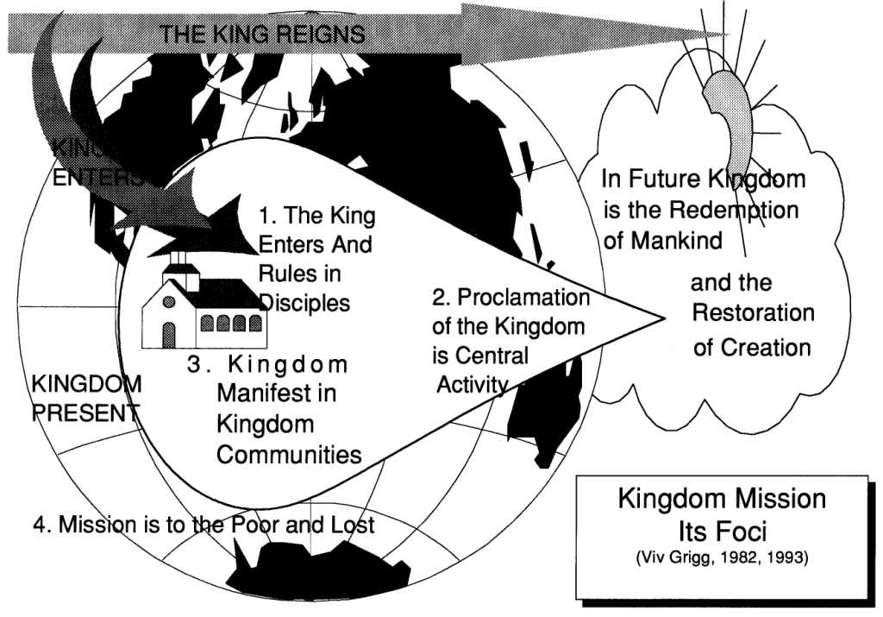
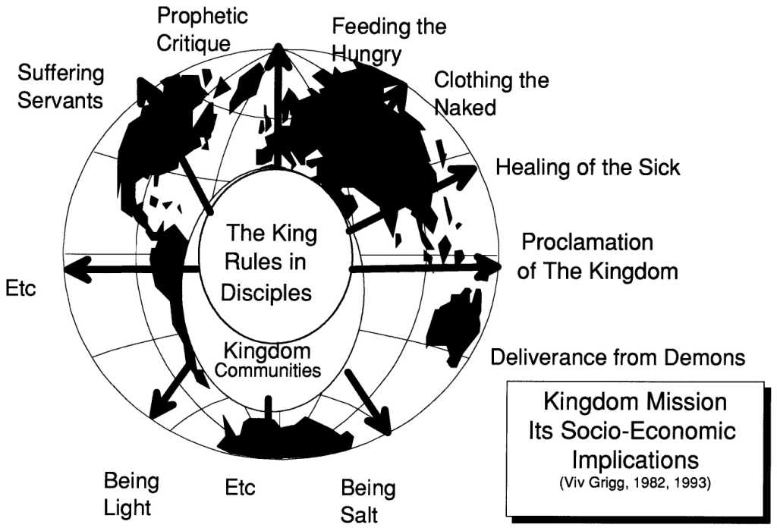

The Kingdom of God and the Poor

Introduction

The emphasis and focus of ministry is to the poor (Luke 4:18)

The model of this ministry is Jesus, who voluntarily became poor among the poor.

How To Define Poverty?

Defined by Latin culture, US culture, African culture, Kiwi culture of by the Bible?

The English Old Testament mentions the word 245 times.

There are 6 main Hebrew roots. We will break them up into three major categories.

A. Poverty Caused by Calamity

“ebyon”- needy and dependent (61 times)

“dal”- frailness and weakness

In the Kingdom of God, the unfortunate poor become the uplifted poor.

B. Poverty Caused by Personal Sin

“chaser”- lack, want, inadequacy (36 times)

Causes:

________ (Prov 13:25)

Sleep (Prov 6:10-11)

Bad Planning (Prov 21:5)

Loving pleasures (Prov 21:17)

Greed, ill gotten gain, gambling (Prov 28:8,22)

Kingdom Response: Preach the gospel (Psalm 23:1), and establish a deep level of discipleship (Psalm 34:10).

In the Kingdom of God, the poor because of personal sin, become blessed through lives of holiness.

C. Poverty Caused by Injustice and Oppression

“rush, yarash” - the destitute ones (31 vezes)

“ani” – the afflicted, the oppressed, the bowed down in humility (80 verses)

“ptochos”- in the New Testament = “anaw”, derived from “ani”

The expression “poor in spirit” has the same meaning as the “poor”, those who respond in their spirits to God because of their oppression It is a statement of an economic reality.

In the Kingdom, the oppressed poor are blessed because justice is done.

A Lifestyle of Simplicity

Earn much

Consume Little

Hoard Nothing

Give Generously

Celebrate Life

The Paradox: Poverty and Blessing?

The poor are blessed.

Poverty is a curse.

The rich are cursed.

Riches are a blessing...

Yet riches are such a danger, that Jesus calls us to give them up (Luke 12:33, 14:33).

The blessing is not in poverty, but in the Kingdom to which the poor respond

The Gospel of Jesus for the Poor and for the Rich

For the rich the gospel is one of judgement which requires repentance (Luke 6:23-26; James 5:1-6).

For the poor, the gospel is one of hope (Matt 11:28), because they are blessed both now and in the future.

Our Reponse? (II Cor 9:8)
Which are your responses?

Forsake all, live simply vs consumerism

Go live among the poor

Preach among the poor

Be involved in meeting physical needs

Work for justice on behalf of the poor

Proclaiming Good News of A Kingdom Jubilee

Viv Grigg, 2002, rev June 2006

DECLARING the JUBILEE
What was the content of Jesus’ Gospel? When people heard him, what did they understand?

Background: Genesis of Work and Rest
God is the first worker and the first rester. When God created he also rested, because he rested this task he was doing must be seen as work. Yet for God this was not toil by any means, but a way to create and express beauty. By resting and reflecting that "it is good" God shows us the example of both what work should be and what rest should be. He rested not out of exhaustion but out of completion and in order to enjoy the work of his hands.
God's work was creative; making something from nothing; out of chaos creating order; through naming bringing into being; His work was artistic. All of these are godly functions of godly work in which we can reflect his image. God's work can be broken down into four different categories: creation, providence, judgment, redemption. These are the tasks of God.
Work was created before the fall and is therefore to be seen as good. Work has received a bad reputation from other cultures whose god's felt that work was beneath them and created humanity to do the work. In the Hebrew tradition work has much honor and can be seen as a holy commandment from God. To till and keep the land.
After the fall work was cursed by God. This did not change the fact that it was still a duty commanded by God. the difference now was that work was toil instead of the creative process that it was originally intended to be. Humanity went from fulfillment to frustration from gardener to farmer. Throughout the Bible work still contains its dignity. David as a shepherd, Saul the farmer. There was no shame in common work. The imagery of tending sheep being a training ground for leading God's people could not be used if this culture looked down on the laborer. (Ryken 1987:119)
Even though there was this high esteem for work there was still the view that work could and was abused. This took two forms: idleness and overwork. Idleness is condemned in Proverbs. It is seen as the path of the wicked. But overwork was also condemned.
Work without rest was one of the major sins warned about by God. The Sabbath was not only a symbol of the covenant between God and his people it was also a time to reflect and rest. The Sabbath was established by God as a day of rest. Rest is a time of reflection of the week. It is out of this reflection that worship is naturally brought out and later established. Rest must include worship. God's rest was a reflection on his work and seeing that it was good. Our rest is a reflection on God's provision and his work combined with our work and obedience and worshipping God because it is good.
God's overall plan is that there is an established pattern between work and rest. Neither are complete by themselves. There is good in rest and refreshment and in production and work. The two are natural fruit of obedience to and worship of God.

The Sabbath (Lev 25:1-7)
Two of the major festivals of Israel are the year of Jubilee and the Sabbath year. The Sabbath was to be an ecological, a societal and an economic rest period. It was to be a time to allow for the recreation of the soil, of the soul and of the society. It was to be a time to remember that it is the Lord who provides - that same Lord who provided manna in the wilderness.
The Sabbath was so important that the Lord exiled the Jews for 490 years, enough to make up for the Sabbaths that had not been kept.
the biblical idea of JUBILEE

The Jubilee (Lev 25:8-17)
The Jubilee, every 50th year, took these values a step further, redistributing the sources of wealth, the means of production of the society. It was a time of equalizing.
I. Liberty
It is synonymous with the year of liberty. Slaves are to be set free. Freedom is inherent in the gospel message.
II. Debts are to be canceled
Economic freedom is inherent in the gospel message.
III. celebration
Celebration is inherent in the gospel message.
IV. Redistribution
The means of production, the land was to be returned to the original owners. Redistribution of the means of production is inherent in the gospel message.

4. Jesus’ Message of the Jubilee
This theme of the Jubilee becomes central to the New Testament, and as such, central to our understanding of the nature of the gospel.
In the central passage around which Luke builds his gospel and the Acts, Luke 4:18, Jesus declares his mission and as he does so, he inaugurates the Jubilee eternally.
Here Jesus declares his commission and ours, his gospel and ours. It was to be good news for the poor? But what could be good news to the poor? What is the master talking about? What is the content of the gospel?
He describes it as a proclamation of freedom, as a release from oppression, as the coming of a special year. What do these phrases mean? These are allusions and references to the Old Testament idea of the year of Jubilee. He is declaring that the Jubilee has come - forever. The rest from oppression, slavery is here, forever.
The scroll he had been given in this little synagogue in the little Jewish enclave of Nazareth, (amid so many foreign villages), contained a passage in Isaiah 61:1 - one of the servant songs, one of the four songs about the coming Messiah. He speaks of the year of the Lord’s favor. The Jews had been exiled because of their disobedience about this year. For 70 years the land was left fallow to recover from 490 years of use without rest. And their expectation was that when they returned, the land would again be blessed by God.
But the expectation was not fulfilled and 400 years of silence from God settled on the land as they awaited a Messiah. So when Jesus quotes this verse he is saying he is the Messiah, the one who brings the Jubilee.
Isa 49:8 calls this year, the time of my favor, the day of my salvation. This day would be a day of covenant, this day would be a day of restoration of the land, this day will be a day when captives, slaves, oppressed people will find their chains fall off. Paul in 2 Cor 6:2 tells us, “now is the acceptable time, now is the time of my favor.” We live in the now of the jubilee.
This is good new for the poor.
I. A Liberating Gospel
This is good new for the poor. To be set free from slavery is surely good news. To be released from oppression is surely good news.
I recall setting free a brother in Hong Kong, Timothy from demons that had been there since he had been thrown out of home. What wonderful joy and new freedom in the life of this young believer! Some years later I came back to find him a leader in the ministry.
And I remember the release of a 22 year old, Simon, from alcoholism. Not once, not all at once. The joy of his new found freedom.
II.An Ecological Gospel
The Jubilee is the restoration of the land, a restructuring of the human-land relationship. We are to manage the land not to abuse it. To manage, to steward is to care for, to protect, as well as to develop the productivity of the land. Jesus aim is to bring all of creation out of its bondage and set it free (Rom 8:21). As the good news of the Jubilee is preached, so the land is allowed to rest. Christians restore the land, they manage the land. But more than that Christians wait for the promised land, the return of the Messiah to rule for 1000 years and bring right relationships to the land.
Evangelism this decade will hinge on Christian leadership of urban and rural environmental issues. As you are working to establish housing for the poor, to enable a community to raise a sustainable food supply, the reason for your care for the land becomes the center of your conversation.
I watched the celebrations, and sudden release of spiritual life when the people of Tatalon a squatter area where I lived were given rights to the land on which they had been illegal for so many years. In involvement with the poor in these struggles we find a ready, open door for the gospel.
The way that the created order can be reinstated to God's original purpose depends upon the proclamation of the Good News (Mark 16:15). Creation groans until the message of the gospel has penetrated to every nation, every person (Rom 8:19,20).
III.A Celebrating Gospel
In the Jubilee, life becomes a celebration. Even within the simplicity of Jesus' lifestyle, he did not consider things as evil. Jesus knew how to enjoy dining with the rich, yet for the sake of the Kingdom of God, he chose to come to a family who could not afford the dedication offering of the poor (Luke 2:24). He was accused of being a party-goer - and he was. He loved life and people. This is where he did his evangelism. For as the proclaimer of Jubilee, he was calling people to celebrate.
Our task is to bring the joy of Christ into situations of darkness, the hope of Christ into situations of despair.
IV.A Reconciling Gospel
Immediately after declaring his mandate, Jesus began to talk about ministering to Gentiles. It seems like it was a big mistake!! the talk turned from respect for this local son to murder. They tried to murder him!!
It was no mistake. The jubilee is reconciling. And that is the basis for a multicultural church.
In New Zealand we developed a cell group among Indian migrants. It grew from four to at times 50. Rejected, jobless, this became the place of love for people. I remember one Hindu lady saying, “I am not a Christian, but this is place where I feel loved each week.”
A successful evangelistic church is based around cells that meet weekly, involving non-believers, and set up evangelistic parties at least once a month.
V.An Economic Gospel
But at heart this declaration is shown by Jesus to be economic. Let us turn to his modeling of this.
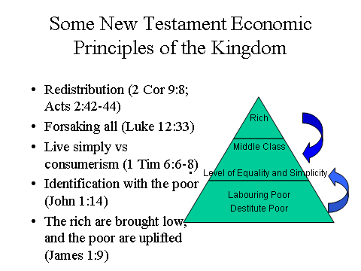

3. Jubilee in the Acts Community and Gospels
In the Old Testament, the economic principles of the Kingdom were seen demonstrated in a nation. Since Jesus' coming, they are demonstrated in communities of believers, communities of the King.
We see these worked out within Jesus’ band of disciples with their common fund, from which they gave to the poor (Matt 26:9). In Acts 4:32-34 that Jubilee is
outworked as the believers sold their possessions, and gave to the poor.
I. First Principle: Celebration
The disciples worked these out also in the Jerusalem community. The first principle is celebration. 'They partook of food with glad and generous hearts' (Acts 2:46). The Jerusalem community celebrated life, enjoyed its goodness, but for the sake of their own souls, for the sake of the Kingdom, and for the sake of the needy deliberately forewent their rights.
II.Second Principle: Sharing
Acts 2:44 'And all who believed were together and had all things in common. The second principle is sharing. This was but an extension of the teaching of Jesus, demonstrated in the common purse of the disciples. It is an extension of the principle in the Old Testament: equality, not an utopian equality, but an equality in spirit that results in an active equalizing.
III.Third Principle: Forsaking
And they sold their possessions and goods (45). Principle three is 'forsaking'. this we've mentioned above. The motivation for such drastic action is threefold:
a. Because one cannot serve God and money.
b. Because of the needs of the battle, the needs of proclaiming the Kingdom
c. Because of compassion for the poor and needy since 'If anyone has this world's goods and sees his brother in need, yet closes his heart against him, how does God's love abide in him' (1 John 3:17).
IV.Fourth Principle: Meeting Needs
'..and distributed them to all. as any had need.' Principle four is to meet the needs of those within the community... The result? a single-mindedness to God, a love for each other and a dynamic witness.
V.Fifth Principle: Private Ownership Without Possessiveness
Acts 4:32 tells us 'the company of those who believed were of one heart and soul, and no-one said that any of the things which they possessed was there own, but they had everything in common.' Principle 5: Some continued to possess things, but they gave up the attitude of protective private ownership.
VI.Sixth Principle: Voluntary Giving
It was a voluntary thing. Acts 5 tells us the story of a couple who tried to cheat God. In verse 4, Peter tells them 'while the property remained unsold, did it not remain your own? and after it was sold, was it not at your disposal?'
VII.Seventh Principle: The Equalizing Gospel
In this community we see the equalizing effect of the gospel. The poor had their needs met.' There was not a needy one among them.' (Acts 4:34). The rich are brought low. Jesus' brother tells us 'Let the believer who is lowly exalt in being raised and the rich in his humiliation' (James 1:9).
For the kingdom uplifts the poor, but the rich refuse to enter it. There is an equalizing effect in the gospel. But at what level is this equality? Do all of us receive a mansion and two cars? No! it is the level of basic needs.
'For we brought nothing into this world and we cannot take anything out of this world, but if we have food and clothing we shall be content' (1 Tim 6:6-8). Basic needs vary according to many factors, so this is not a fixed level - a family of 12 needs more than a single person. It is a voluntary lifestyle. The outward action depends on the inner values. Some call it a simple lifestyle. For most it is a sacrificial lifestyle where we learn to depend on our heavenly father for our basic needs rather than become anxious (Matt 6:25-33).

4. Jubilee and International Redistribution (2 Corinthians 8,9)
The principles of Jubilee as evidenced in Jesus community, then in the Acts
community are further extended globally in Paul’s teaching on global redistribution between the churches.
What does this mean for us? We are to share from our resources so that others are uplifted, so all come to some level of equality and justice.

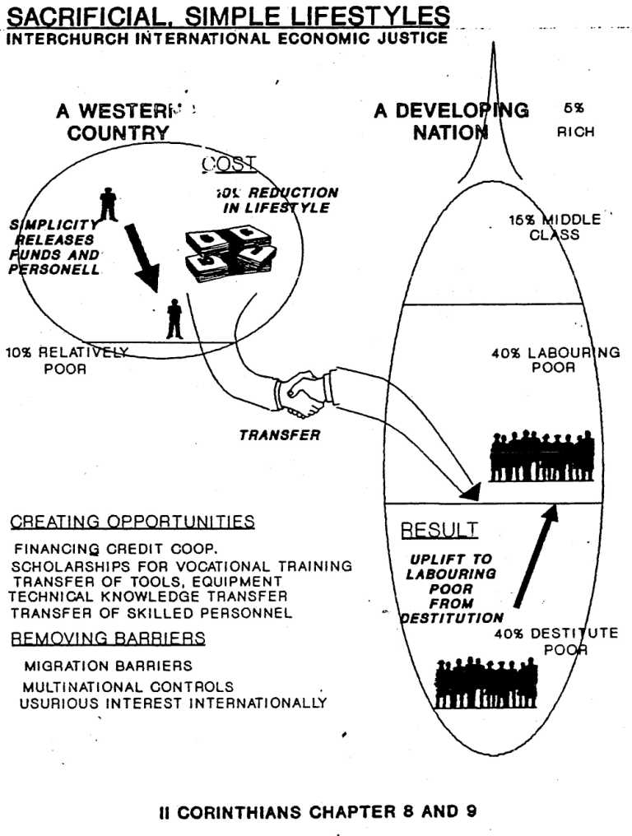

5. Work and Leisure in the New Testament
With a new role to proclaim the Kingdom, and a new community to demonstrate it, do we still need to work? This was the question of the Thessalonians, who were so expectant of Christ's return to establish his Kingdom that they stopped working.
Christ like the Father , places a high regard upon work, by labeling himself a worker (Jn 9:4, 4:34, 5:17). He also is very familiar with the jobs of the poor and the rich of his time. The use of these parables enabled him to teach in a way that he would be understood, but it also places a high regard upon work. If our work gives glory to God or it serves humanity then it can be seen as a Kingdom job (Ryken 87).
Alongside our food producing jobs we have a primary job that all children of the kingdom must do. Our primary work is now to be laborers in the Kingdom reaping a harvest (Matt 9:37,38) but to do this we need 'to aspire to live quietly, to mind your own affairs and to work with your hands, as we charged you; so that you may command the respect of outsiders, and be dependent on nobody' (1 Thes 4:11,12). We now work for a new set of motivations:
a. to extend the kingdom, by commanding the respect of outsiders.
b. to be dependent on nobody and
c. to support others. (Acts 20:35), both the needy and those involved in proclaiming the Kingdom.
d. The thief must learn to work with his hands (Eph 4:28) so as to give to those in need.
Education in the scriptures is always considered good. Knowledge is essential to wisdom. In acquiring knowledge we learn of God. Working at a good education honors God.
A full-time worker is to be supported because of his hard work (2 Tim 2: 1-6). 'The laborer is worthy of his wages.' (1 Tim 5:18) However the normal approach of the early church was to depend on laymen and lay elders who supported themselves. When an older man had proven his worth he was to be 'worthy of double honor.'
Rest is also a key part of life for those who are part of the Kingdom. Leisure can be defined as a time free from the constraints of work and other obligations of living. It is a time to cultivate an enriched state of being. Jesus was the herald of the kingdom and he taught us what resting in the kingdom should look like.
The first and foremost leisure time for Jesus was his time of prayer in a lonely place. Jesus, in order to enrich his state of being, turned to his relationship with the Father for help. He knew that this was the priority of the kingdom when it came to rest. The other form of rest came in the form of fellowship. Jesus loved to spend time both with regular people and his disciples. This for him many times was rest and he called his disciples to rest with each other (6:31).

6. Debt and Lending in the New Testament
i. Debts
The basic principle here is Rom 13:8 'Owe no one anything,' since 'the borrower is servant of the lender.' (Prov 22:7). so if you can pay your debts do so today (Prov 3:27,28). There is no pautang-utang (debt of gratitude) in the Kingdom of God. We are to work to support ourselves, to live within our means, and we are to look after our poor.
ii. Charitable Loans
In lending to a poor believer we lend without interest (Lev 25:36). Since 'they who are kind to the poor, lend to the Lord' (Prov 19:17). Indeed Jesus takes the principle of giving generously even further in Luke 6:34,35. We should lend, expecting nothing in return, being unconcerned with the fact that it cannot be repaid.
Good will come to those who lends freely, conducting his affairs with justice (Psa 112:5). There is no 5:6 in the Kingdom of God. If a poor person is so poor that the only collateral they have is their coat, return it to them that day (Lev 25:26; Deut 24:10-14).
Since the poor get poorer and eventually become slaves, the Lord commanded periodic canceling of debts and release of those who had been enslaved (Lev 25:10).
Don't make loans to strangers (Prov 6:1-5; 11-15; 20:16; 27:13) and don't countersign a note unless you have extra cash (Prov 22:26,27).
iii. Commercial Loans
Notice that all the above instructions are in the context of lending to help people get out of 'personal poverty.' It appears that at the time of the Exodus and on into the Monarchy borrowing capital for business was not highly practiced.
In modern society, commercial loans are considered as a way of giving money to a person to manage for a fixed length of time. This person through business of investment is to make money-enough for himself and enough to repay the back capital plus interest.
Do not borrow on depreciating asset (i.e. on things that will decrease in value) since the loan will not increase your money and you will be unable to pay it back (e.g., Do not borrow money to buy a motorcycle for personal use since it decreases in value yearly. On the other hand, if you borrow to buy land or a motorcycle to extend your business contacts you will make money, since land always increases in value and business contacts bring more income). If this advice is followed Rom 13:8 will be fulfilled 'Owe no one anything.'
O Peter don't you call me, cause I can't go,
I owe my soul to the company store.
IV. Partnerships
II Cor. 6:14 tells us not to be mismated to unbelievers in marriage. This applies to business also. In a partnership, all partners take responsibility for management decisions. If your partner is not a Christian, you cannot be sure of their honesty, and certainly they will not be seeking as their primary objective to extend the Kingdom of God, through their business dealings. This does not mean we do not work under or employ non-Christians or relate to them. The issue here is one of responsibility for decisions

8. The Jubilee and its Implication for Economic Theories
II Cor 8:9 tells us of Jesus economic mission. Grace somehow comes from this incarnation. And that grace creates life. When the church is planted somehow it creates life and that life is economic. II Corinthians 8:3 They gave first of themselves. Explosive power of word. That word is power, the power of the spirit against the economic power of the world.
i. Ownership
The principle of Jubilee is clearly based on the premise that the land belongs to the Lord, and we are stewards of that land. That stewardship is to be exercised on behalf of all.
ii. Production
Gospel creates a new productive system as new communities emerge. I came to this as I was thinking about why the slums generate their own economic systems. A continual influx of people creates new wealth, new markets. So in a growing church there is an increasing amount of resources set free for the Kingdom.
Fundamental principal of production in the Kingdom is that of giving. II Corinthians 8:2,15 The world's system is one of getting. Biblical Economics starts in the cross as it cuts our basic instinct to acquire.
Out of the giving, comes mustard seed production. When I arrived in the States I had US$400 in hand. With this we generated 30 workers living and working among the poor over five years.
iii. Distribution
God didn't intend exact equality but he did intend justice and levels that feel equal and free and creative.
There is no teaching on tithing in the New Testament. But there is teaching here on sacrificial giving. A good starting point is tithing. We can move money to the poor as we have workers among the poor.
4. Jubilee, Justice and Peacemaking
We will seek to uplift the economy of the poor by working where possible to get the skills to produce, the means of production and control of production into the hands of the laboring poor. This involves assisting those in the richer nations or classes in transferral of technology, tools of production, and initiating capital to the poor. We will encourage the development of cooperatives , home-based industries, and vocational training. Our intended model is development from within communities based on existing and developing values, skills and motivations of the poor, rather than large-scale externally imposed projects.
We recognize that the freedoms of democratic capitalism have enabled the most significant uplift of the poor in history because of its rewards for productivity through profits. Free market economies also are more compatible with Biblically-based concepts of the freedom of the individual than other state-controlled economies. But we seek to develop, modify and bring justice into existing systems by our renunciation of anti-biblical presuppositions inherent in capitalism of values of greed, excessive profit, usurious interest, the exploitation and dehumanization of man as a machine, and the exhausting of irreplaceable natural resources.
We renounce the centralization of power in elites as being contrary to Biblical principle, either power of an economic Capitalist elite or of a political socialist elite. We work rather for cooperative patterns of development with power diffused as much as possible to local community leadership, recognizing that the multiplication of small grass-roots economic, political and spiritual organizations aids in the diffusion of power, uplift of the poor and protection of freedoms within a nation.
We seek to bring biblical values of justice and equity also into the international arena of the usurious international banking and trade systems.

REFERENCES
Darragh, Neil.
2000 At Home in the Earth. Auckland: Accent.
Eller, Vernard
1973 The Simple Life. Hodder
Hengel, Martin
1974 Property and Riches in the Early Church. SCM Press.
Sider, Ronald J.
1977 Rich Christians in an Age of Hunger. Inter-Varsity Press. A masterly analysis. Very biblical and comprehensive.
Snyder, Howard
1985 A Kingdom Manifesto. IVP. An excellent summary integration of the theological debates on the Jubilee.

?Snyder, Howard. 1997 A Kingdom Manifesto. Wipf and Stock Publishers. The Jubilee is not being ushered in as an year but as an age.
See the following for definitions of who are the poor. Perkins, Harvey L. c 1980 Bible Study on The Poor and Oppressed; the focus of Christian participation in human development. In Colleagues in Development Bible Study Series Singapore Christian Conference of Asia.
Darragh, Neil. At Home in the Earth. Auckland: Accent, 2000.
Grigg, Viv. 1985 The Lifestyle and Values of Servants. Auckland: Urban Leadership Foundation.

